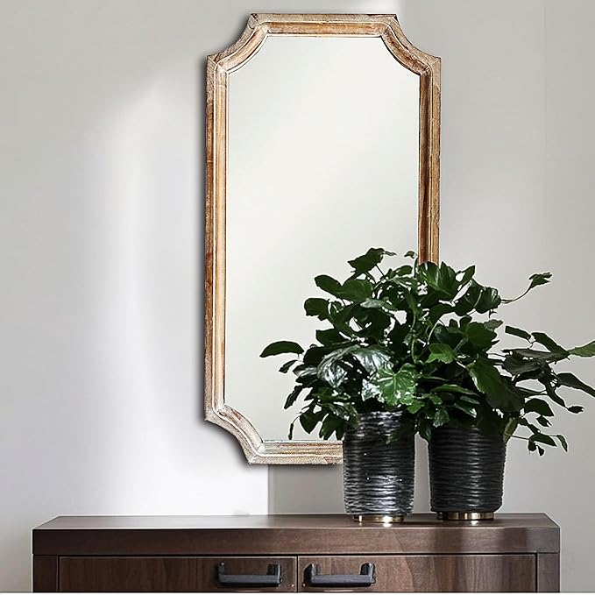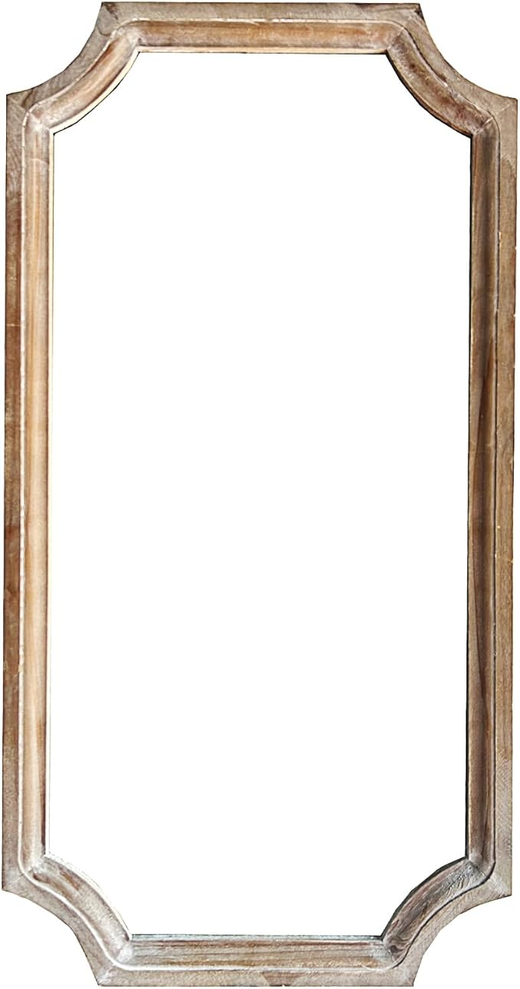

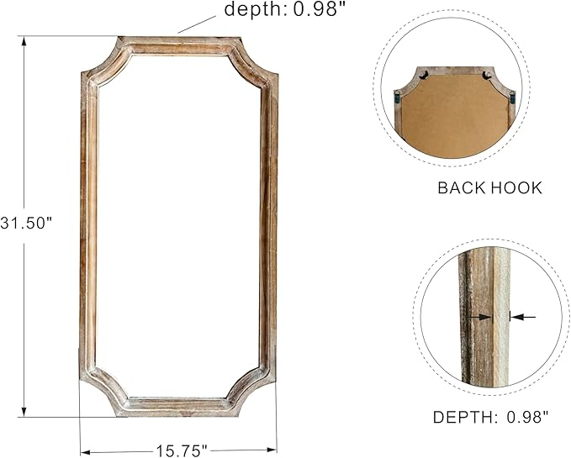

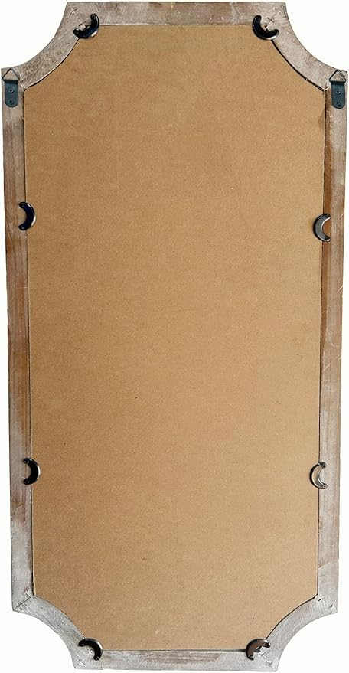

32" Vingtage French Mirror with Wooden Frame in Classic Arched Shape in Shabby Brown Finish for Farmhouse, Cottage, Attic for Bathroom, Living Room, Bedroom and Drawing Room

**PRODUCT DESCRIPTION :**

|  |  |
| --- | --- |
| **Brand** | **twakutwaku** |
| **Room Type** | **Bathroom, Bedroom, Living Room, Hallway** |
| **Shape** | **Classic Arched** |
| **Product Dimensions** | **32"L x 16"W** |
| **Frame Material** | **Wood** |

**About this item**

Sizes: 16"x1.2"x32" H

Classic French Style

Farmhouse and Cottage decoration

The frame is made of solid wood

Well packaged

Easy installation